**Product Analysis Using Hadoop:**

**Introduction:**

DataCo is a company that wants to know what products their customers like to buy. To find out, they can look at the data of all the transactions made by customers. This data tells them what customers buy and what they like. Normally, they would use a regular database system to analyze this data. However, Apache Hadoop is a special system that allows them to do this analysis on a larger scale and at a lower cost. Hadoop can also be used for other types of analysis, so it's a versatile tool. To use Hadoop for analyzing the transaction data, they need to transfer that data into a special storage system called Hadoop Distributed File System (HDFS). They want to do this without changing or breaking any of their regular reports or analysis processes. To transfer the data from their regular database system to HDFS, they need a tool that can do it easily. This tool should also keep the structure of the data intact, so they can still query and analyze it properly. By using this tool and transferring the data to HDFS, they can then use Hadoop to analyze it without interfering with their regular analysis processes. In simple terms, DataCo wants to use a special system called Hadoop to find out what products their customers like to buy. They need to move the data from their regular database to Hadoop without causing any problems, and they have a tool to help them do that.

1. Connecting to the Azure Labs.

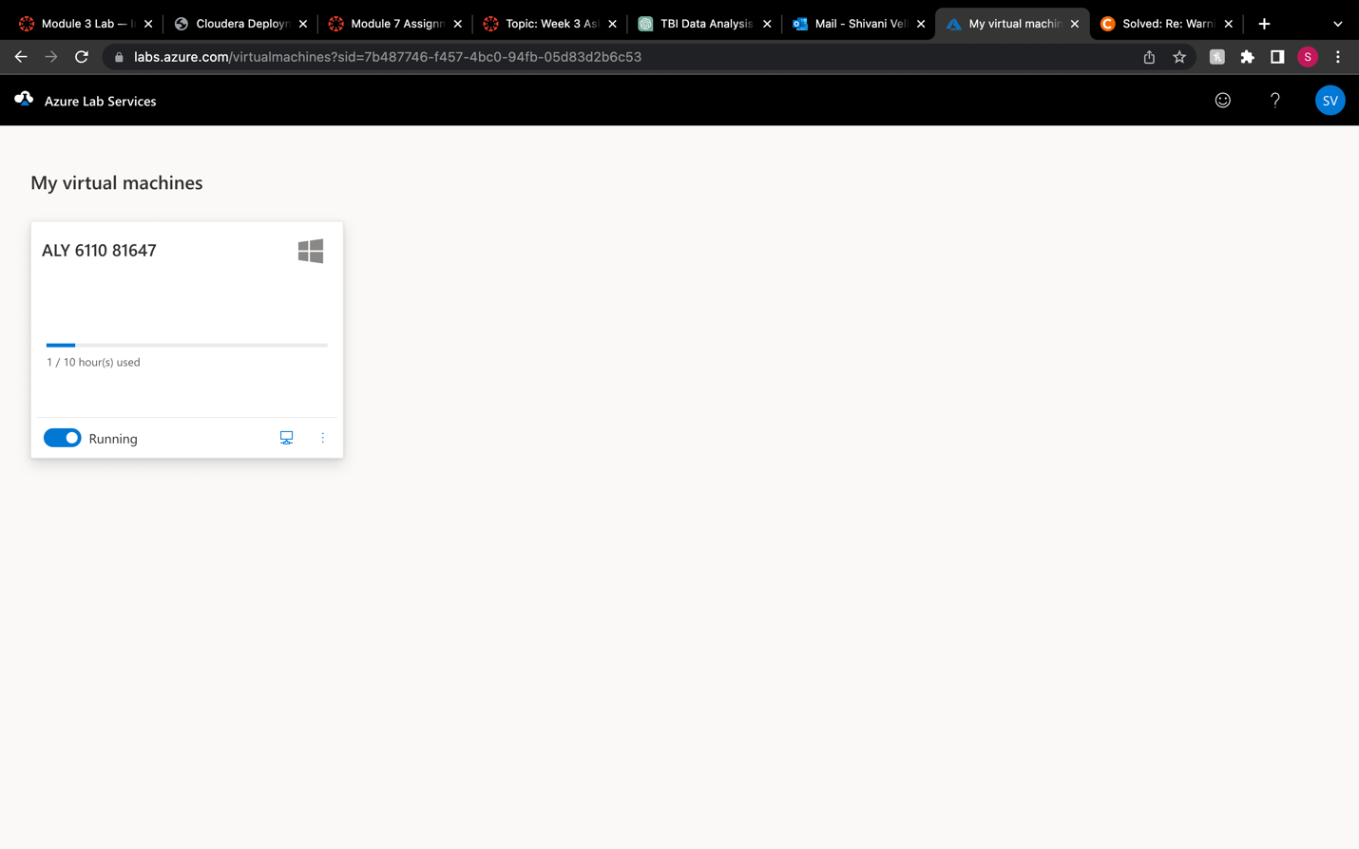

1. Starting the Cloudera VM

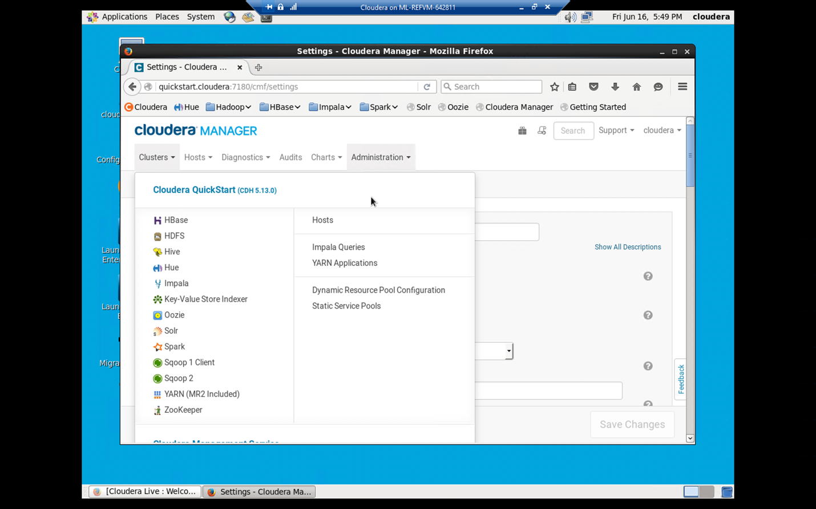

1. Running the Sqoop ingest query to ingest data from RDBMS to HDFS

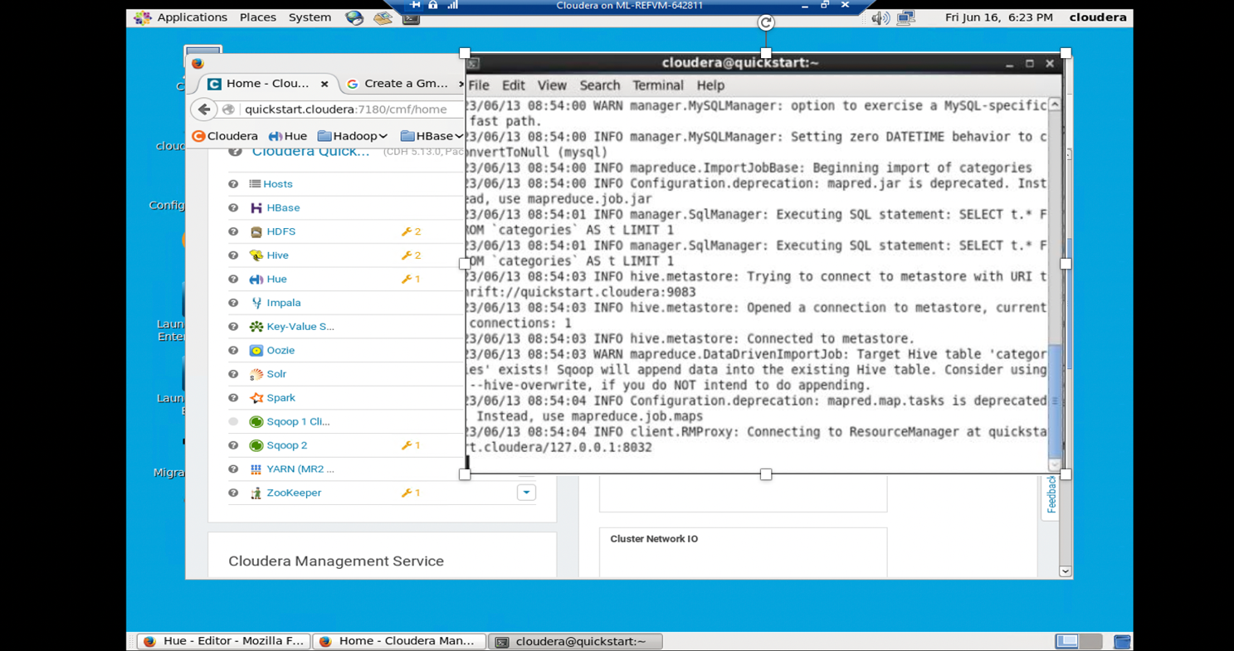

4. Once the data is ingested into HDFS and subjected to MapReduce, it is retrieved for further processing.

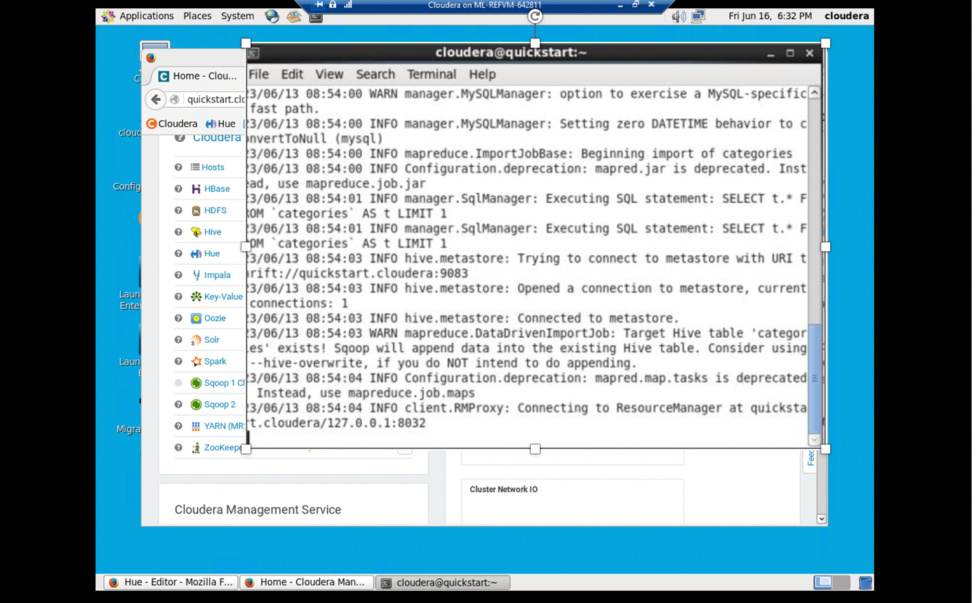

5.Traversing to hue and querying the below

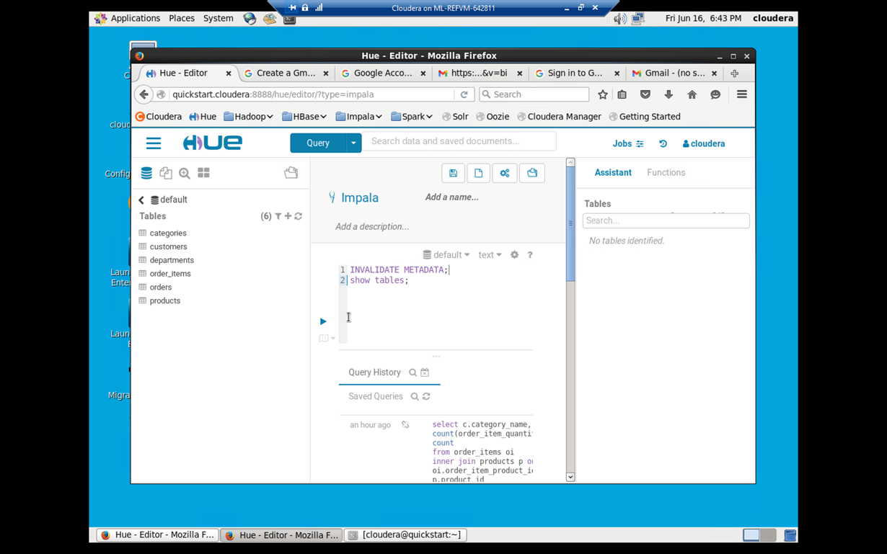

6. Output:

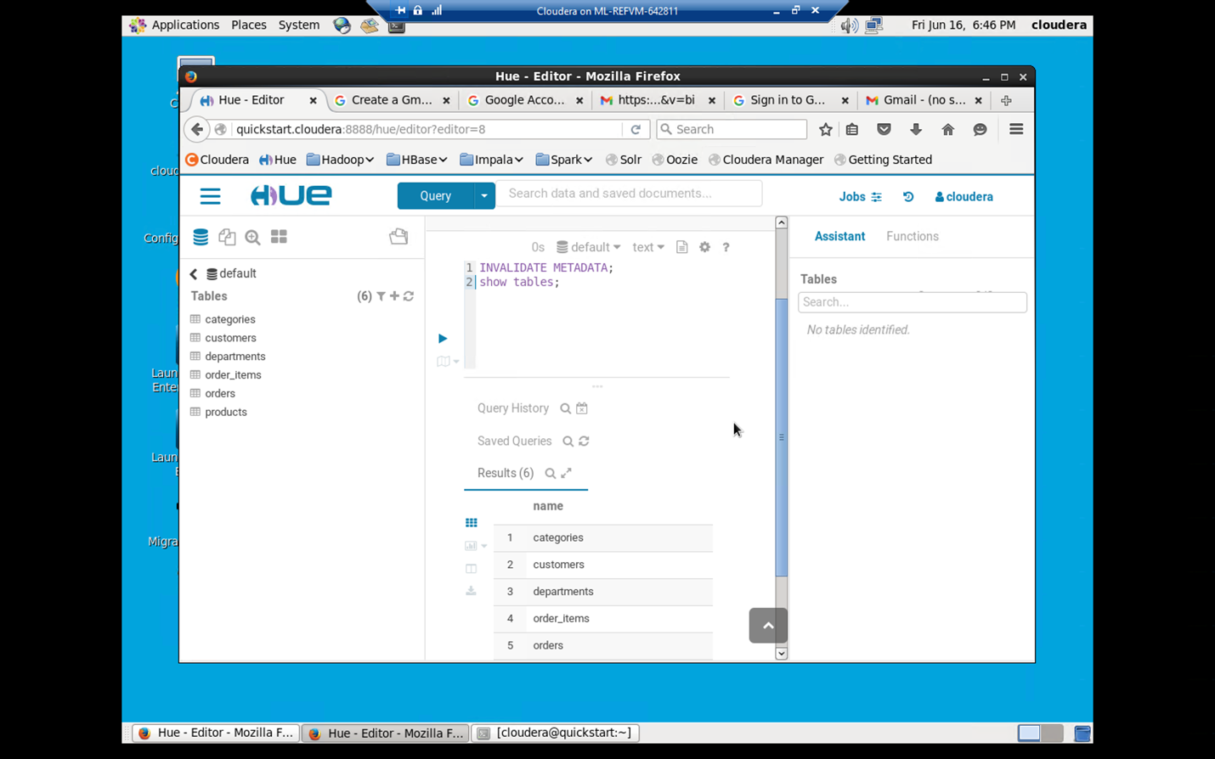

7.

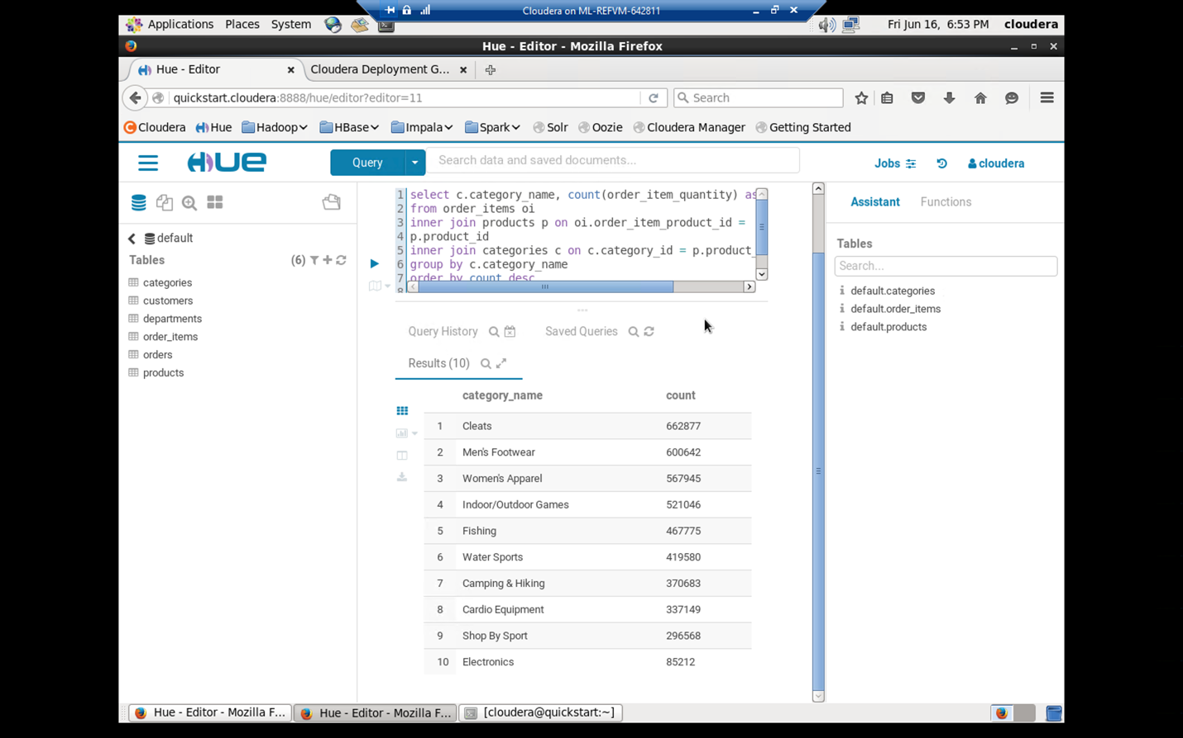

8. Most revenue generating products.

What is the 5th most revenue generating product.?

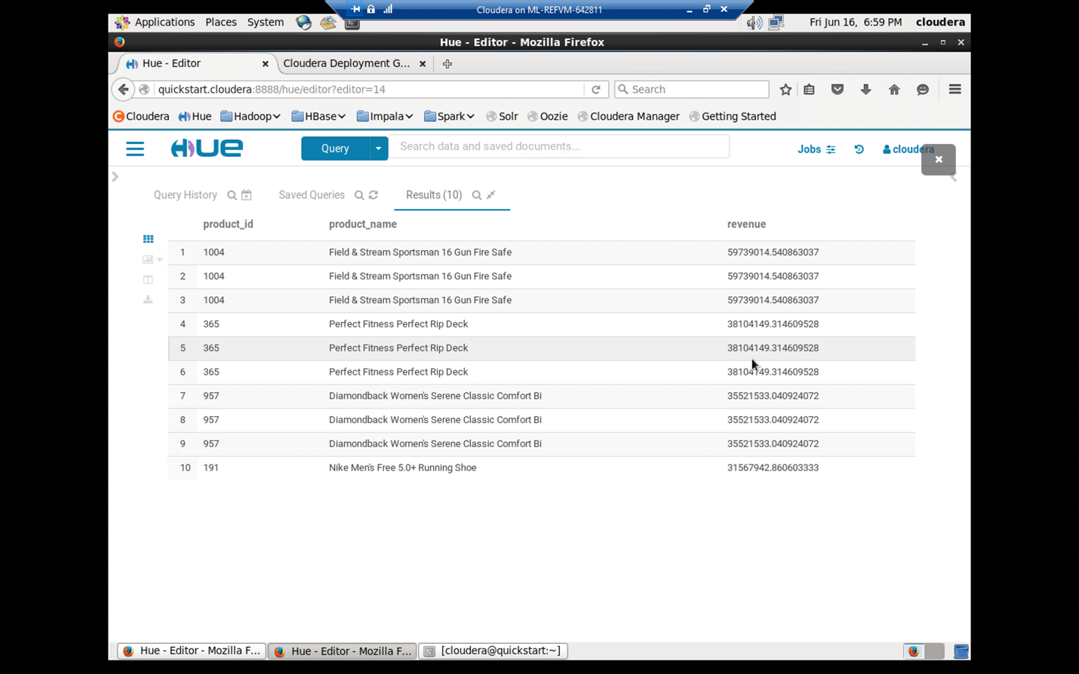

How much revenue does the Nike men's dri-fit polo earn?

Nike’s revenue



Exercise 2:

There is one product that did not show up in the previous result. It seems to be viewed a lot, but never purchased. Why?

Directory to access logs

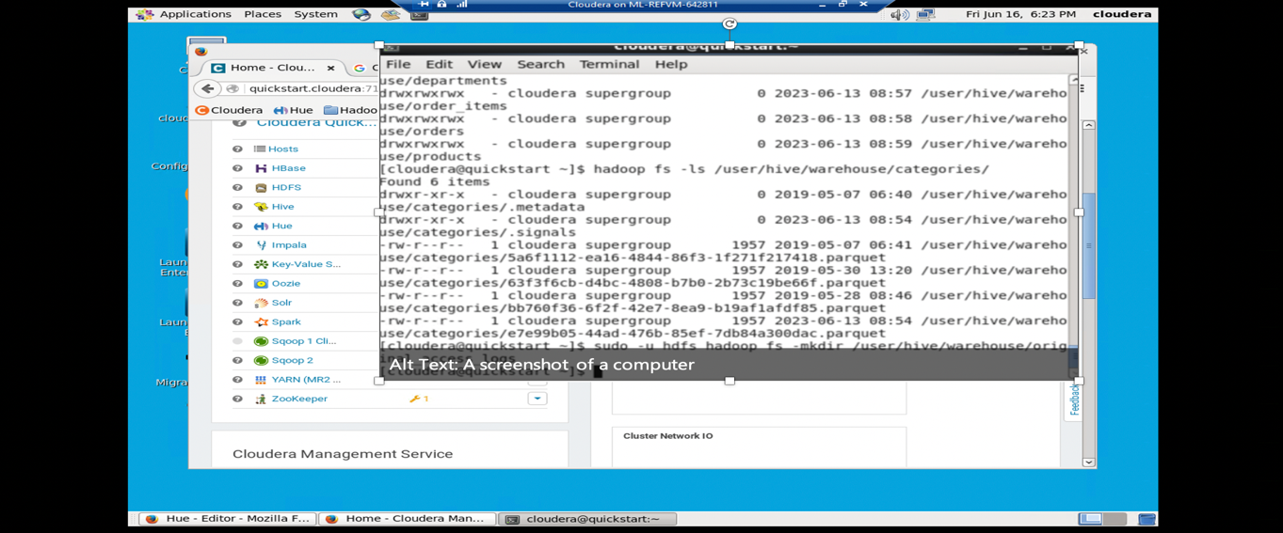

Moving the data from local file to HDFS

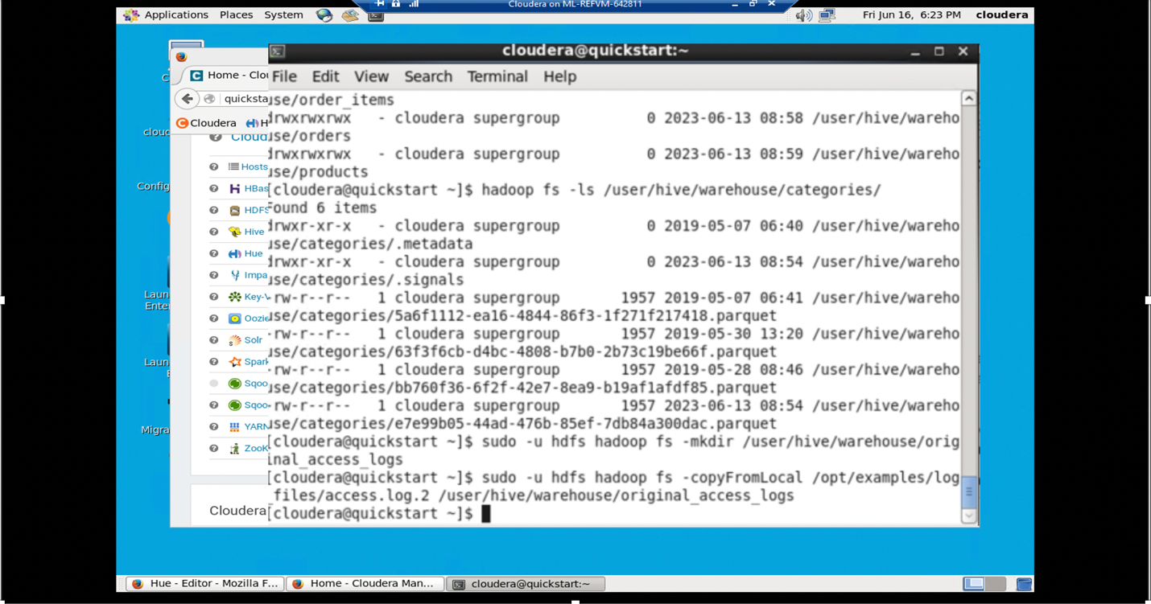

Access logs

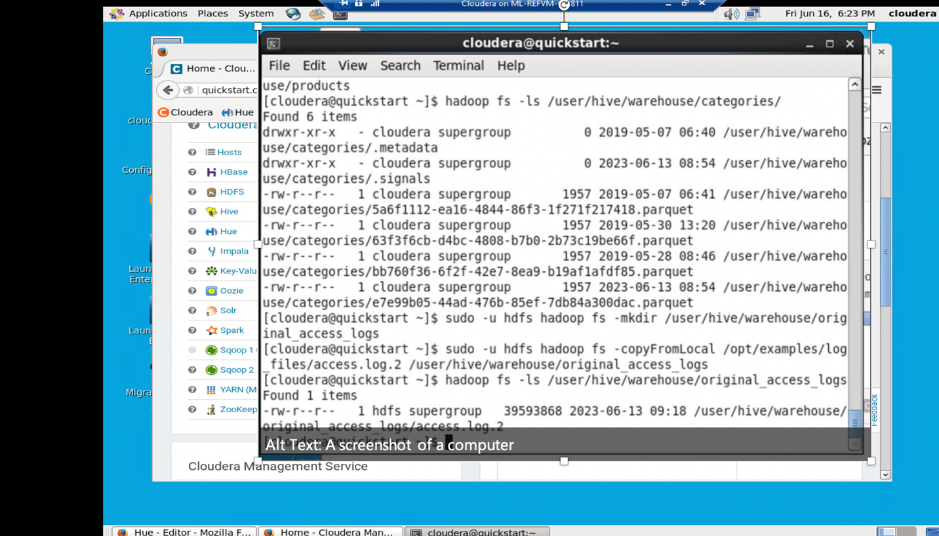

Creating external intermediate access table

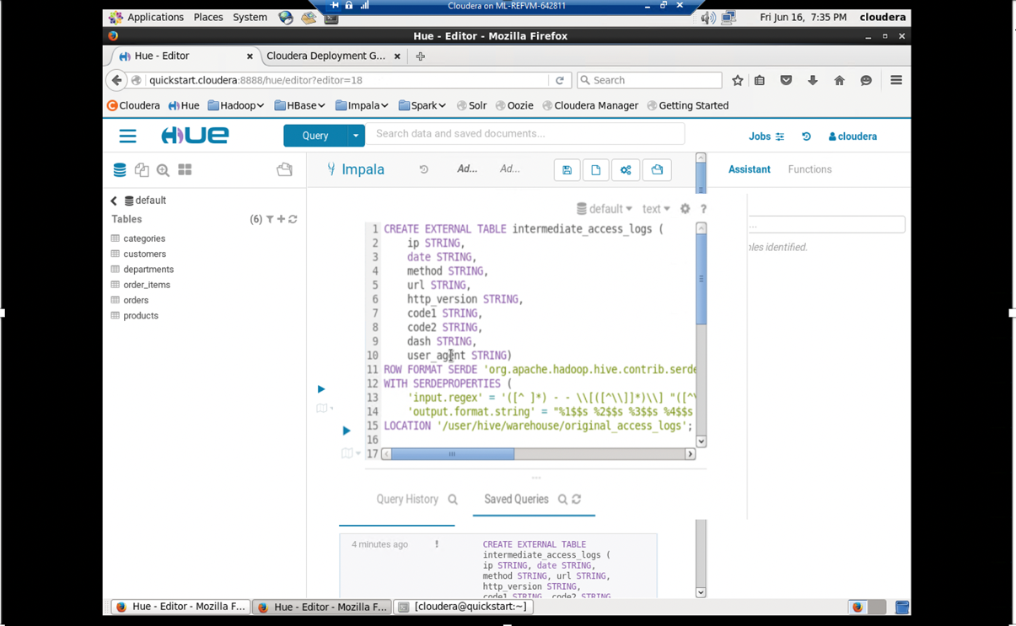

Add Jar Files.

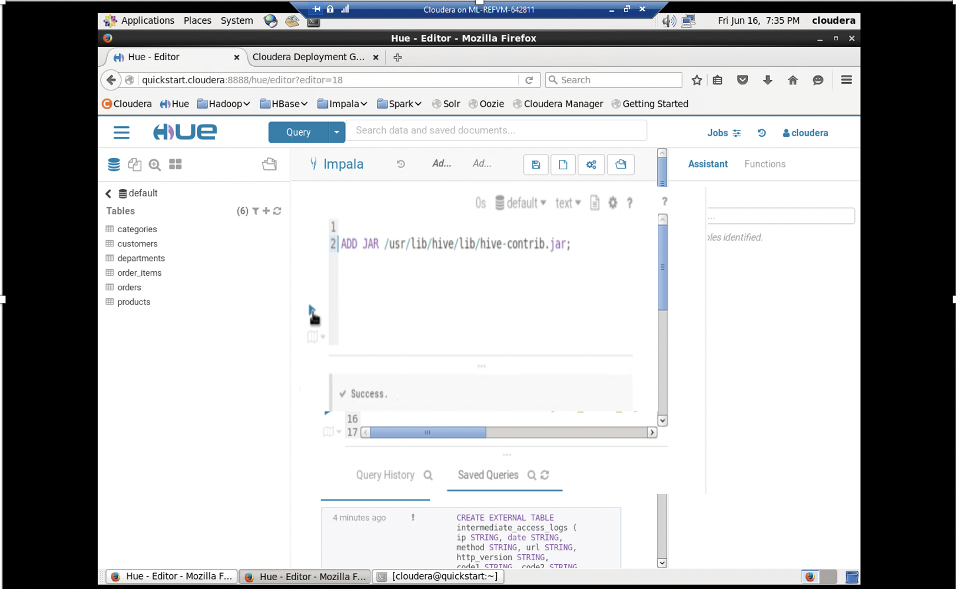

Access logs

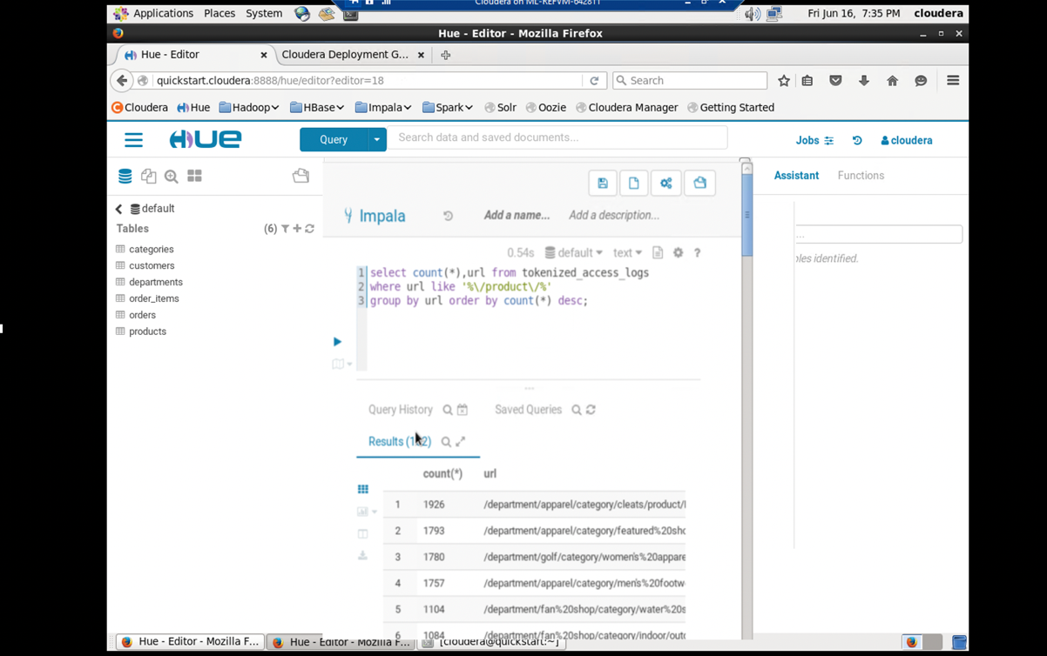

Reference:

<https://www.cloudera.com/content/dam/www/marketing/documents/partners/ungated/cloudera-msazure-hadoop-deployment-guide.pdf>